Dc motor speed control(PID simulation)

Simulates dc motor dynamics with PID controller

Inputs: motor parameters, controller gains

Outputs: speed vs time, control performance

Libraries: control, matplotlib

Application: robotics, electric drives

Source code:

#dc motor speed control pid simulation

motor_params={

"R":1.0,

"L":0.5,

"K":0.01,

"J":0.01,

"B":0.1

}

print("motor_parameters:",motor_params)

import matplotlib.pyplot as plt

speed=[100,500,300,400,250]

time=[0.1,0.2,0.3,0.4,0.5]

plt.plot(time,speed,marker='h')

plt.xlabel('time(sec)')

plt.ylabel('speed(rpm)')

plt.title('time vs speed')

plt.show()

Output:

motor_parameters: {'R': 1.0, 'L': 0.5, 'K': 0.01, 'J': 0.01, 'B': 0.1}

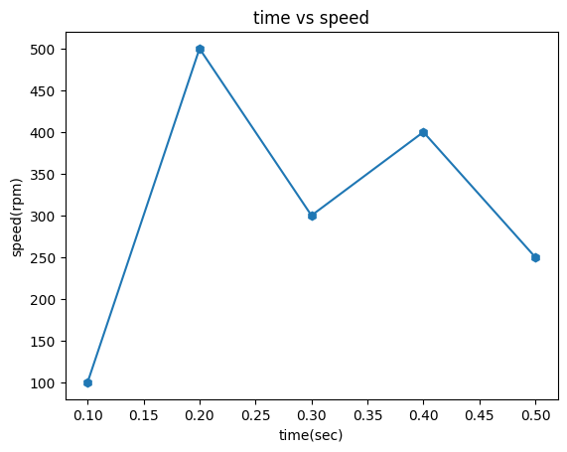

Conclusion:

A PID (Proportional-Integral-Derivative) controller effectively regulates DC motor speed by minimizing error between a desired speed and the actual motor speed. Through proportional, integral, and derivative actions, the PID controller adjusts the motor's input to achieve and maintain the desired speed, even under varying load conditions.